ALX AICE: Milestone #4 Worksheet

# SECTION Zero

**Step 0: Completed Survey**

Complete the placement survey by [clicking here](https://theroom.formstack.com/forms/placement_l3?utm_source=lms&utm_medium=aice). After completion, take a screenshot of the thank you page and paste it below. Once done, go back to Savanna to continue your learning journey.

***To take a screenshot on Windows, use Alt + PrtScn***

***To take a screenshot on Mac, use Shift + Command + 5***

***You can use Ctrl + V or Command + V to paste the screenshot in be box below.***

Kindly complete the [survey by clicking here.](https://theroom.formstack.com/forms/placement_l3?utm_source=lms&utm_medium=aice)

**Step 0: Completed Survey**

|  |
| --- |
|  |

# SECTION A: Visualized Data

**Step 1: Visualized Data**

To complete this activity, you need to access the ["UN Data on Refugees (AiCE <> Dataset)"](https://docs.google.com/spreadsheets/d/12ELmgxSyxIAr54tpoNJFIbDdK8kdYfMf_2I1s43a1AY/copy) dataset and make sure you have visualized the data given to you.

*To do this:*

First, find the total number of refugees in each country using Tab 1 (Data) Tab.

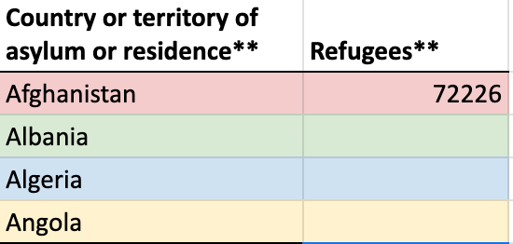

Once you have done that, make sure you have visualized the data using a Bar Chart, Pie Chart [(Activity: Visualize Your Dataset (Part A))](https://intranet.alxswe.com/concepts/102401), and your visualized data from Julius AI [(Activity: Visualize Your Dataset (Part B))](https://intranet.alxswe.com/concepts/102402).

After that, you need to paste the link to the copy of your worksheet. Please ensure that the link you are pasting can be viewed by anyone, and the setting should be set to "anyone with the link can view."

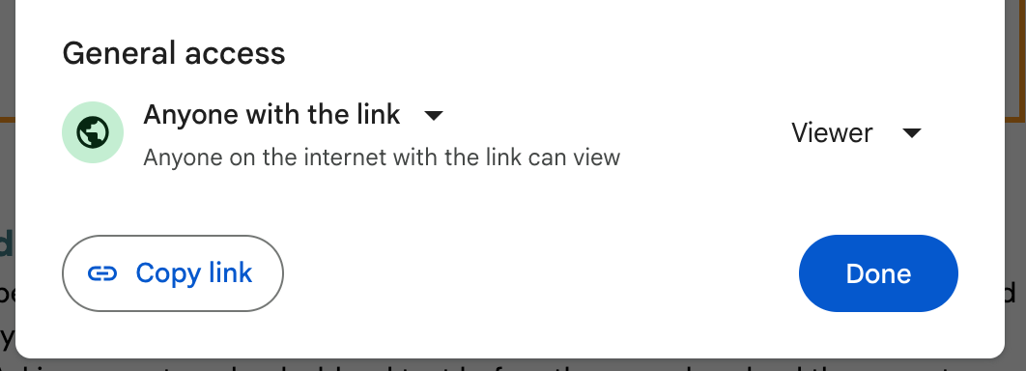

**Step 1: My Visualized Data**

|  |
| --- |
| https://docs.google.com/spreadsheets/d/1V4LBea2j_fWLfU3MzN5ZILxTXtArSDqG5U8Du9xeXH4/edit?usp=sharing |

# **PAUSE HERE AND GO BACK TO SAVANNA!**

# 

# SECTION B: User persona

**Step 2: User persona**

Paste the links to both user personas from this activity in the box provided below, and ensure your user persona has the correct file name.

The user persona was created manually with Canva, in Part A of this activity: [Create Your User Persona](https://intranet.alxswe.com/concepts/102349)

**Step 2a: Manually Created Userpersona**

|  |
| --- |
| https://drive.google.com/file/d/1fIYGws8h6z74ughNQNJoUMQ_o0Nz41na/view?usp=sharing |

The user persona was created with user persona dev in Part B of this activity: [Create Your User Persona](https://intranet.alxswe.com/concepts/102349)

**Step 2b: AI Created Userpersona**

|  |
| --- |
| https://drive.google.com/file/d/1RuH40GDYHvNLoE05MQ8NlCeBubLJdkfl/view?usp=sharing |

# **PAUSE HERE AND GO BACK TO SAVANNA!**

# 

# SECTION C: Before Your Peer Meeting

**Step 3: Restate your problem statement**

Please write your problem statement from week 2 here *(This is the problem statement you wrote based on your simulation activity at Waga).*

**Step 3: My Problem Statement**

|  |
| --- |
| *The decline in vacation sales and customer dissatisfaction with VacAI, a recently launched product by Waga, poses a critical challenge for the company. The problem arises from a gap between the promising usage metrics in the first week and the subsequent sharp decline in customer satisfaction during the second week. This issue directly impacts the population of Waga's customer base, leading to a surge in refund requests and a potential negative impact on the company's reputation. The discrepancy between the initial excitement and the subsequent drop in satisfaction highlights a crucial gap in delivering a consistently high-quality user experience. Addressing this gap is imperative to not only regain customer trust but also to align VacAI with the company's commitment to excellence in the hospitality industry.* |

**Step 4: Bad Idea Brainstorm**

BEFORE your peer meeting, conduct a Bad Idea Brainstorm with yourself. List at least 10 bad ideas for how you might solve the failed launch of VacAI. You can get completely ridiculous. For example: Asking users to upload a blood test before they can download the app, etc. The dumber the idea, the better! The purpose of this is to get your mind open to generating ideas without fear of them being wrong, dumb, or bad. (Stay in divergent thinking.)

Need help? Click **“Give Me a Bad Idea**” on this website <http://labs.jackpine.co/projects/FirstBadIdea/> to get some inspiration.

**Step 4: Bad Ideas**

|  |
| --- |
| 1. Implementing a psychic service requiring users to guess and choose their ideal vacation, completely bypassing the need for an app.  2. Transform VacAI into a virtual reality experience, simulating extreme and unrealistic vacations that are logistically impossible in reality.  3. Ship users a box filled with random items and instructions, claiming it's a personalized vacation experience. No app needed, just open the box and go!  4. Instead of predicting the weather at vacation destinations, provide users with the worst possible weather forecasts to surprise them with unexpectedly good conditions.  5. Turn VacAI into a matchmaking service, connecting users with potential travel buddies solely based on their vacation preferences and not personal compatibility.  6. Simplify the booking process by allowing users to choose their vacations using only emojis, leaving room for interpretation and potential chaos.  7. Distribute virtual fortune cookies within the app, with vacation suggestions hidden in cryptic messages. Users would need to decipher their next destination like a fortune teller.  8. Introduce a premium service where users are lifted to their vacation destination by hot air balloons, offering a scenic but impractical mode of transportation.  9. Communicate all travel details exclusively in Morse code, challenging users to decipher and decode their vacation plans in a cumbersome and archaic manner.  10. Transform VacAI into a truly random vacation generator, completely disregarding user preferences and assigning vacations purely based on chance. |

**Step 5: Possible ideas**

Next, list at least 5 “possible ideas” to address the problem with VacAI. These do NOT have to be good ideas. The only constraint is that they should just be at least theoretically possible. It could be adding a simple user onboarding process or introducing an entirely new dashboard. You’re still in Divergent thinking here, so don’t judge your ideas as good or bad.

**Step 5: Possible Ideas**

|  |
| --- |
| 1. Introduce a virtual celebrity travel companion option within VacAI, allowing users to experience their vacation alongside a simulated celebrity of their choice. 2. Implement a gamified approach to vacations by introducing interactive challenges and tasks for users to complete during their trips, enhancing engagement. 3. Add an element of surprise to each day of the vacation by incorporating daily mystery activities or destinations, keeping users engaged throughout their trip. 4. Enhance the user experience by integrating localized virtual tour guides who provide real-time information and recommendations based on the user's current location. 5. Introduce an augmented reality feature allowing users to create and share virtual memories from their vacations, enhancing the post-trip experience and fostering community engagement. |

Once you finish this section, follow the steps mentioned below to find a peer for your next activity. A peer refers to a fellow student/learner enrolled in this AiCE program, and you are allowed to choose up to three peers for the peer activity. However, while filling out Section D in your Milestone #4 worksheet, you only need to report on one chosen peer. This peer meeting should be online on any platform of your choice.

**Step 1: Reach Out to a Peer**

**1: Message one of your peers in your** [**Squad on The Portal**](https://member.theroom.com/community#s/ai-career-essentials/)**.** If you don't have a Squad, you can reach out to a peer from the main AiCE Learner Community on [**The Portal.**](https://member.theroom.com/community#s/ai-career-essentials/)

* Request to complete this activity with them.
* Schedule a date and time that works for both of you.

**2: Complete Section C of your Milestone #4 Worksheet**

* Before showing up for the peer activity, make sure you have completed Section C of your Milestone #4 Worksheet. This will help you to be better prepared for the feedback you will receive.

PLEASE BRING THE ABOVE WORK WITH YOU TO YOUR PEER MEETING.

# **PAUSE HERE AND GO BACK TO SAVANNA!**

# SECTION D: PEER Meeting Output

**Step 6: Meeting Date, Time, & Location**

Please list when and where your team meeting took place.

**Step 6: Meeting Date, Time, & Location**

|  |
| --- |
| 1. Date: 15/03/2023 2. Time: 15:00 pm 3. Location: Microsoft Teams 4. Peer Name: Negoma Ampfarisaho |

**Step 7: Selected Solution**

Choose and specify the idea you are going with.

**Step 7: Selected Solution**

|  |
| --- |
| One idea to enhance the VacAI app is to introduce a personalized recommendation system based on user preferences and past travel experiences. By leveraging machine learning algorithms, the app can analyze user behavior, interests, and demographics to suggest tailored vacation options. Additionally, integrating real-time feedback mechanisms within the app can allow users to provide ratings and reviews, enabling continuous improvement and customization of recommendations. This personalized approach can enhance user satisfaction, increase engagement, and ultimately drive higher conversion rates for vacation bookings. |

**Step 8: Peer's Feedback**

Please state which idea your peer found the most appealing during the conversation and explain the reason for their choice.

**Step 8: Peer's Feedback**

|  |
| --- |
| During the conversation, my peer found the idea of introducing a personalized recommendation system based on user preferences and past travel experiences to be the most appealing. They were particularly intrigued by the potential of leveraging machine learning algorithms to analyze user data and provide tailored vacation options. The peer appreciated how this approach could enhance user satisfaction by offering personalized recommendations that align with individual preferences and interests. Additionally, they recognized the value of integrating real-time feedback mechanisms to continuously improve and customize recommendations, ultimately leading to higher engagement and conversion rates for vacation bookings. |

**Step 9: Reflection**

In a brief paragraph, describe your experience with peer coaching, including what went well and areas for improvement.

**Step 9: Reflection**

|  |
| --- |
| My experience with peer coaching has been enriching and rewarding. I found that the collaborative exchange of ideas and feedback fostered a supportive environment conducive to personal and professional growth. Engaging in active listening and constructive dialogue allowed me to gain valuable insights from my peer's perspectives and experiences. Additionally, providing feedback to my peer enabled me to reflect on my own knowledge and skills while contributing to their development. However, there are areas for improvement, particularly in ensuring clear communication and setting mutual expectations at the outset of the coaching relationship. Additionally, establishing more structured frameworks or guidelines for providing feedback could enhance the effectiveness of the peer coaching process. Overall, I believe peer coaching is a valuable tool for continuous learning and development, and I look forward to further opportunities to engage in this practice. |

**Step 10: Email to Stakeholders**

Paste your email from the [Activity on email writing to stakeholders](https://intranet.alxswe.com/concepts/102403) in the box below.

**Step 10: Email to Stakeholders**

|  |
| --- |
| Subject: Update on VacAI: Innovative Ideas and Next Steps  Dear Waga Stakeholders,  I hope this email finds you well. As we wrap up this week's simulation activity, I am excited to share the progress we've made on addressing the challenges faced by VacAI. The idea generation process has been both enlightening and challenging, pushing us to think outside the box and explore unconventional solutions.  We've explored a spectrum of ideas to rejuvenate VacAI, ranging from implementing a psychic vacation planner to a virtual reality extreme vacation experience. While some ideas were intentionally humorous and impractical, they paved the way for more viable solutions. The final proposal involves introducing an interactive element with daily surprise vacation elements, keeping users engaged throughout their trips. This approach aims to enhance the user experience and address the decline in customer satisfaction.  Reflecting on the week's experiences, the ease of generating diverse ideas was notable. The AI's contribution in brainstorming sessions facilitated divergent thinking and allowed us to explore a wide range of possibilities. However, refining these ideas required a human touch, as certain nuances and practical considerations demanded a more personalized approach. The collaboration between AI and human creativity proved to be a dynamic and productive process.  We have incorporated these insights into the VacAI prototype, and I am excited to share the updated version with you next week. The prototype will showcase the innovative features, emphasizing the daily surprise vacation elements and interactive challenges. This step aligns with our commitment to delivering a consistently high-quality user experience and regaining customer trust.  Thank you for your ongoing support, and I look forward to presenting the prototype to you in our upcoming milestone submission. If you have any immediate questions or feedback, feel free to reach out.  Best regards,  Ntokozo Matsipa  Junior AI Analyst  Waga Simulation Team |

**Step 11: AI Toolkit**

To access your AI Toolkit, Go to your personal ALX AICE Google Drive, then locate your updated [AI Toolkit Spreadsheet.](https://docs.google.com/spreadsheets/d/11HJQIo3FncvMSBTs4fZ413aPBSmLrhXnfoXx5dqoeqA/copy) Make sure your AI Toolkit is updated and contains prompts and workflow optimization processes from the following activities:

* Visualizing Data Using Julius AI
* User Persona
* Email to Stakeholders

Next, Click **"Share"** (under the 3 dots) and adjust the settings so that it looks like this:

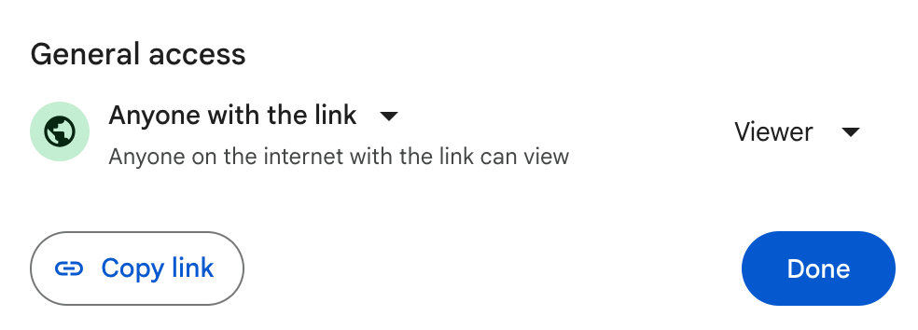

# **Then, copy the link and paste it in the box below;**

**Step 11: Your AI Toolkit**

|  |
| --- |
| https://docs.google.com/spreadsheets/d/1HtCFZDpkrLJlDGTw6fJi8aQ1hmOwe_KF3O_aiznZFCc/edit?usp=drive_link |

*If you need more help with this, Google for video instructions on sharing files in Google Drive, or ask a peer.*

**Step 12: Reflection on the use of AI**

Take a moment to reflect on how you used AI this week, you are to write a short paragraph answering the following reflection questions:

**Reflection on the use of AI**

|  |
| --- |
| *1. How did AI assist you in the writing process? Did it help you generate ideas, proofread, or edit your work?*  *2. Did you feel that AI helped you save time or improve the quality of your writing?*  *3. What potential drawbacks or limitations did you experience while using AI for writing?*  *4. How did you use AI for prototyping? Did it help you create and refine designs or models?*  *5. In what ways do you think AI can improve the prototyping process, and how might it be limited?* |

**Step 12: Write Your Reflection Response Here**

|  |
| --- |
| AI played a pivotal role in streamlining the writing process, offering multifaceted support throughout various stages. From generating creative ideas to proofreading and editing, AI provided a versatile toolkit. The assistance not only saved valuable time but also significantly enhanced the overall quality of the written content. However, some limitations were evident, particularly in fine-tuning nuanced aspects that require a human touch. While AI contributed to the prototyping process by aiding in generating and refining designs or models, its true potential lies in furthering collaboration and innovation within the field. By addressing the nuanced elements of creativity and refining collaborative functionalities, AI has the potential to become an invaluable asset in the prototyping landscape, overcoming current limitations and fostering a seamless integration of human ingenuity and machine intelligence. |